How to Guide for the use of the iAssessor ISO Logo and use of the combined iAssessor ISO Logo and UKAS Mark
Use of the iAssessor ISO Logo
First well done on achieving your ISO certification for your company’s management system. It is not an easy thing to achieve…so well done to You and all the staff at your business.
You will want to maximise recognition of your company’s achievement. Which is only natural.
A copy of the ISO certificate from iAssessor will be sent to You which can be placed at reception – for all staff and visitors to see…but what about stationery, your company website or putting the logo on the side of vehicles. Consider for a moment…
Did you know that there are certain places the ISO logo should not be placed? Doing so would send a misleading message to customers or prospective customers. You can down load a copy of the ISO logo from iAssessor website, but firstly let me explain the dos and don’ts when using the iAssessor logo/s…
Do’s
- Where to place the logo. The logo can be placed on stationery, vehicles, advertising, promotional goods, flags, window stickers, boundaries, signs and corporate clothing.
- What colour. iAssessor would prefer you to use the black and white colour provided. As this is the easiest format to read.
- What size. iAssessor has no requirements regarding how large or small you make the logo.
Don’ts
- Where not to place the logo. The logo should not be placed on products, laboratory test reports, calibration reports or in association with services or location not covered under the scope of certification;
What about Packaging?
You can’t put the ISO logo on product packaging. Customers could think the product has achieved a certification standard rather than the management system. You can however place text on packaging saying your business has achieved ISO certification for its management system.
There are regulations controlling the use of text on product packaging or paperwork that accompanies the product. You have to ensure text is clear about stating the company’s management system is certified to ISO 9001: 2015 or ISO 14001: 2015 or ISO 45001: 2018 there can be no inference of product certification. The text should not imply that the product, process or service is certified.
The text shall include:
- Identification of the certified client eg your company’s name;
- The management system ISO 9001 Quality or ISO 14001 Environmental or ISO 45001 Safety and Health Management System;
- The certification body issuing the certificate ie iAssessor.
Find below the iAssessor logo (this logo can be placed on vehicles once you have achieved certification with iAssessor)
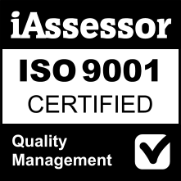  UKAS Accreditation 8414 | Once your company has achieved ISO 9001: 2015 you can download a jpeg of the iAssessor logo for ISO 9001 for Quality Certification.  *Suitable to place on vehicles to promote certification to this standard
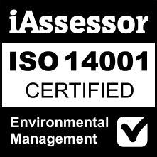  UKAS Accreditation 8414 | Once your company has achieved ISO 14001: 2015 you can download a jpeg of the iAssessor logo for ISO 14001 for Environmental certification.  *Suitable to place on vehicles to promote certification to this standard
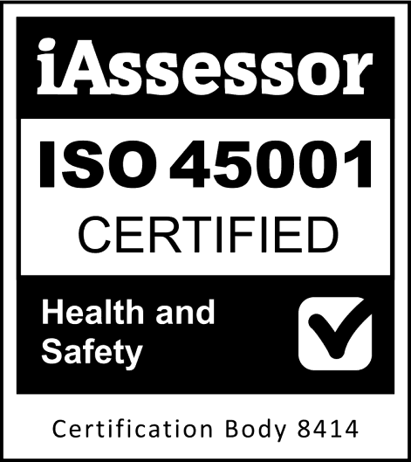 | Once your company has achieved ISO 45001: 2018 you can download a jpeg of the iAssessor logo for ISO 45001 for Health and Safety certification.  *Suitable to place on vehicles to promote certification to this standard

There is a second option…
Use of the iAssessor logo and the UKAS Mark
The advantage of using the iAssessor logo and UKAS tick and crown mark in one, is that it adds recognition. It adds the reassurance that your ISO system is certified by a UKAS accreditation certification body.
There are some extra requirements in using the combined iAssessor certification logo with the UKAS ‘tick & crown.” Let me explain...
- When copying and applying to your website or other promotional material use the format shown for the iAssessor certification logo (with UKAS ‘tick & crown’) shown below.
- Do not reduce beyond a minimum of 20mm and a maximum height of 30mm if printed on a sheet of A4 paper. (increasing the logo size above 30mm must be proportionate to the size of the overall location)
- A reduction below 20mm is allowed where cost or space limits, as long as all parts of the logo are reproduced proportionately and the logo remains legible.
- Use black when reproducing the UKAS logo. Or in a single colour the colour predominant in the location.
- The iAssessor logo with UKAS tick and crown is controlled by regulations. The National Accreditation Logo & Symbols: Conditions for use by UKAS and UKAS accredited organisations published 2013.
- Do not separate the iAssessor logo from the UKAS tick and crown logo. Or apply the UKAS logo separately. Or change the size proportions between the logo and mark.
- Reproduce the iAssessor Logo in full including the accreditation number 8414.
- Do not describe holding an eg ISO 9001 certificate as an accreditation. The description in promotional material or the company website should he described as gaining ISO certification or holding certifications.
Where You can apply the iAssessor logos with UKAS tick and crown mark:
Do’s
- Where to place the logo. The logo can be placed on stationery, advertising and publicity material. Except for promotional products such as calendars/diaries/mugs. The promotional material should relate in whole or part to the product or services described in the scope of Your ISO certification. Signs. You are permitted to have signs with the iAssessor log plus the UKAS tick and crown mark applied to inner walls, doors and exhibition stands, but not on a site boundary, external walls or flags.
- What colour. iAssessor would prefer you to use the black and white colour provided. As this is the easiest format to read.
- What size. iAssessor has no requirements regarding how large or small you make the logo.
Don’ts
- Where not to place the logo. The logo should not be placed on vehicles, on products, laboratory test reports, calibration reports or in association with services or location not covered under the scope of certification;
- Do not reproduce the iAssessor logo/UKAS tick and crown mark on vehicles.

Find below the iAssessor logo with UKAS crown and tick Mark. (The combine logo and mark should not be placed on vehicles)
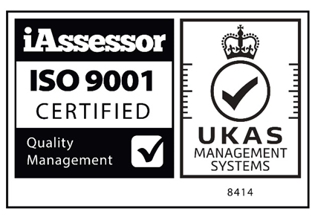 | Click on the download icon on the iAssessor website to download a jpeg of the iAssessor logo with UKAS mark for ISO 9001  *This logo and mark should not be placed on vehicles
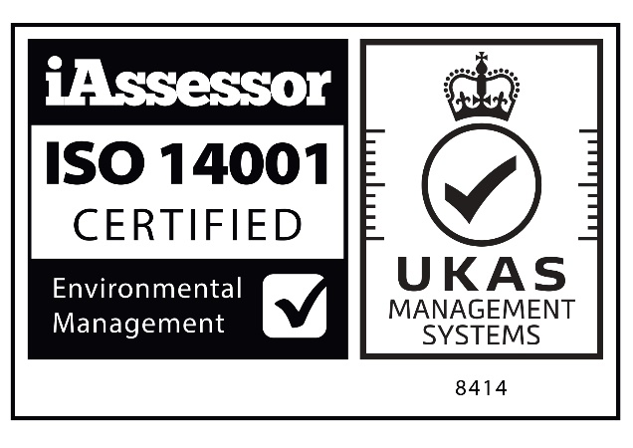 | Click on the download icon on the iAssessor website to download a jpeg of the iAssessor logo with UKAS mark for ISO 14001  *This logo and mark should not be placed on vehicles
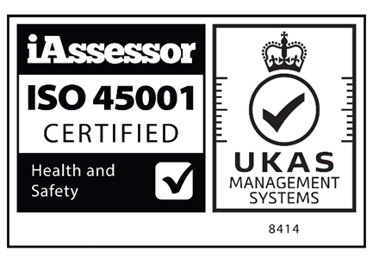 | Click on the download icon on the iAssessor website to download a jpeg of the iAssessor logo with UKAS mark for ISO 45001  *This logo and mark should not be placed on vehicles

Background
As a UKAS accredited certification body we follow the ISO 17021 standard. That standard provides instructions when it comes to the use of the ISO logo. Here are the two key clauses…
International Standard ISO 17021: 8.3 Reference to certification and use of marks:
8.3.1 A certification body shall have rules governing any management system certification mark that it authorizes certified clients to use. These rules shall ensure, among other things, traceability back to the certification body. There shall be no ambiguity, in the mark or accompanying text, as to what has been certified and which certification body has granted the certification. This mark shall not be used on a product or product packaging or in any other way that may be interpreted as denoting product conformity.
Note: ISO/IEC 17030 provides requirements for use of third-party marks.
8.3.2 The certification body shall not permit its marks to be applied by certified clients to laboratory test, calibration or inspection reports or certificates.
8.3.3 A certification body shall have rules governing the use of any statement on product packaging or in accompanying information that the certified client has a certified management system. Product packaging is considered as that which can be removed without the product disintegrating or being damaged. Accompanying information is considered as separately available or easily detachable. Type labels or identification plates are considered as part of the product. The statement shall include reference to: identification eg brand or name of the certification body, the type of management system eg quality or environmental and the applicable standard, the certification body issuing the certificate.

Thank you for reading. If you have any questions regarding the use of the iAssessor logo or the logo and mark feel free to contact iAssessor by email on info@iassessor.org

